Financial Lit Name: _______________________

______________ _____________

WS Assessment

Target 15:

Place to live

**I can:**

* Calculate the affordability of a monthly rent.
* Determine the relationship between square
* footage and monthly rent.
* Determine lease signing costs.
* Calculate moving expenses

**Unit 7 Math Topics:**

* Area and scale factor
* Area of irregular regions
* Bar graphs
* Exponential regression
* Greatest integer function
* Literal expressions
* Monte Carlo method Probability
* Rational and exponential equations
* Scale drawings
* Scatterplots and linear regression
* Spreadsheets and formulas
* Systems of linear equations and inequalities in two variables

Have you ever imagined what it would be like to have a place of your own? For many teenagers, the usual progression of living arrangements is from family home to dorm room to apartment to homeownership. Finding a place to live isn’t easy. There are many decisions to make.

Your first experience in independent living will probably be in a rented **apartment**. When you rent an apartment, you are the **tenant**, and the owner of the apartment is the **landlord**. Before you move into any apartment, you must sign a lease. A lease is a written agreement between the landlord and the

tenant that details the amount of rent and the length of time that you will rent the apartment. The lease states the rules and regulations that must be followed by the tenant and the landlord. If, for any reason, a tenant stops paying rent, they have defaulted on the lease, and may be **evicted** from the apartment.

While renting is a suitable option for many, others find owning a home is their goal. There are many options for ownership. You can purchase a single-family home, a multiple-family home, a condominium, or a cooperative.

Alex makes $61,992 per year and pays about 25% of his gross monthly income in federal and state taxes. He wants to find an apartment to rent. The recommended rule is to budget 25% to 30% of the

gross income for rent, (a good estimate to use is 28%). Estimate how much he can afford to pay for rent each month. Then determine how much money he will have after taxes and rent are paid.



Rufus and Maria have both been offered new jobs in a different city. A real estate broker sent them a listing of apartments in their desired location showing the square footage in each apartment. Use linear regression analysis to determine if there is a correlation between the square footage of

rental property and the amount charged for the monthly rent. What is the linear regression equation? Interpret the correlation coefficient.

Show for stamps

Google doc desmos

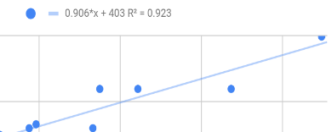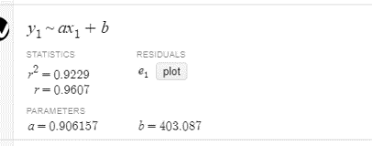

**Lease Signing Costs**

It isn’t enough just to have the first month’s rent available. There are a number of fees that are associated with the rental of any property. Usually, there is an **application deposit**. This amount, which is sometimes refundable, may vary between $100 and $400. It covers the cost of processing the application for the rental. Often a credit report is required. The fee for this report is usually under $25.

A **security deposit** is money given to the landlord from the tenant as protection in the event that the tenant causes damage to the rented property. This deposit is refunded when the tenant moves out if there is no damage. The security deposit can range from 1 to 4 month’s rent. In addition to the first month’s rent paid in advance, many landlords also require the last month’s rent to be paid at the time of move in. This protects the landlord in the event that the tenant decides to break the lease and vacate the apartment earlier than agreed in the contract.

Rufus and Maria paid a $200 application deposit for the 1,150 square foot apartment (listed above). They are required to provide a credit report that costs $25 and pay a security deposit equal to one

Month’s rent. The landlord also requires the last month’s rent at the time of signing the lease. The broker charged 10% of the yearly rent. How much should they expect to pay to be able to move into the

apartment?

**Moving Costs**

Jay is moving from an apartment in Miami to one in Orlando. If Jay moves on a weekday, he will need more movers’ time to pack, load, unload, and unpack because his friends will not be able to help him. If

he moves on a weekend, he can get his friends to help, cutting down on the number of hours he will need to hire movers. MoveOut is a moving company that supplies movers, trucks, and moving equipment. They have given him the following moving estimates.

**Weekday Move Weekend Move**

6 hours of loading/unloading 4 hours of loading/unloading

5 hours of packing/unpacking 2 hours of packing/unpacking

$720 total cost $400 total cost

MoveOut charges a set hourly moving team rate for loading and unloading, and a different set hourly moving team rate for packing and unpacking. Determine the MoveOut hourly rates.

Solve by algebra and desmos for stamp.

A moving helper company gave Mike these two quotes. Use a system of equations to determine the hourly rates for loading/unloading and packing/ unpacking.



A **floor plan** is a drawing of

the layout and dimensions of rooms. The floor plan shown is for a one-bedroom apartment. Here is some of the information that the floor plan shows you:

• This apartment has a kitchen, a dining room, a living room, a bedroom, and a bathroom.

• The bathroom has a sink, a toilet, a bathtub, and one window.

• The bedroom is 15 feet by 12 feet; it has two windows

and one doorway.

• The living room is 20 feet by 12 feet; it has one large window and three entrances, one being the outside entrance.

• The dining area is 8 feet by 7 feet and has three entrances and no windows.

• The kitchen has cabinets, counter space, a sink, a stove, a refrigerator, one window, and one entrance

Gabriela plans to carpet her living room, except for the quarter-circle shown in the corner. That area will be a wood floor where she will put her piano. The radius of the quarter circle is 8 feet. If carpeting costs

$9.55 per square foot, what is the cost of the carpeting she will use in her living room?

Delgado’s Landscape Design is building a large gazebo for a backyard. It is in the shape of a regular octagon as shown. Each side of the gazebo is

10 feet. They need to purchase wood for the floor. It costs $14 per square foot for a special type of wood. Find the cost of the gazebo’s floor.

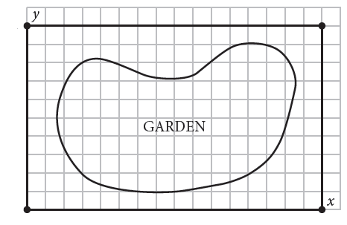Don sculpts out a region for a flower garden, as shown. He takes a digital as shown. The area of the garden impacts the cost of mulch, plants, fertilizer, and so on.

What is the area of the garden? (google Pick’s theorem, Monte Carlo method Probability)

Mike’s bedroom measures 16 feet by 14 feet, and has a 9-foot ceiling. It is well-insulated and on the west side of his house. How large of an air conditioner should he purchase?

Note: Air conditioners are sold according to their BTU (British Thermal Units) rating. The air conditioner with the right BTU rating will cool and dehumidify a room. If the rating is too low,

the room may not cool sufficiently. If the rating is too high, it may shut off before removing the humidity. Many appliance salespeople use the formula known as “*while* divided by 60” to compute the correct BTU rating.

In this formula, *w* represents the width of the room, *h* represents the height, and *l* represents the length. The level of *insulation* is represented by *i*. If the room is well-insulated, i = 10, and if the room is

poorly insulated, i = 18. The variable *e* represents the *exposure*, the direction the outside wall of the room faces. If it faces north, e = 16. If it faces east, e = 17. If it faces south, e = 18, and if it faces west, e = 20.

BTU rating $≈\frac{while}{60}$

A rectangular room measures 13 feet by 15 feet. It is going to be carpeted with carpeting that sells for $68 per square yard. What is the area of the room in square feet?

If the room is drawn to ¼ inch represents 1 foot-scale, give the dimensions of the room in inches on the scale drawing.

A yard equals 3 feet. How many square feet are in a square yard?

How many square yards will it take to carpet the room? Round up to the next greater integer.

What is the total price for the carpeting?

In the early mid-2000s, there was a dramatic increase in the price of carpeting, since it was a petroleum-based product. As a result, selling by the yard made it look expensive. Some stores started

selling carpet by the square foot. How much would a square yard of carpet selling for $8.95 per square foot cost?

This room is well-insulated and is on the south side of the house. It has an 8-foot-high ceiling. How large an air conditioner would this room require? Round to the nearest thousand BTUs.



Write a story problem that ask for the area of the shaded and solve it.

**Assessment Target 15**

* **I can…** Calculate area and of irregular regions

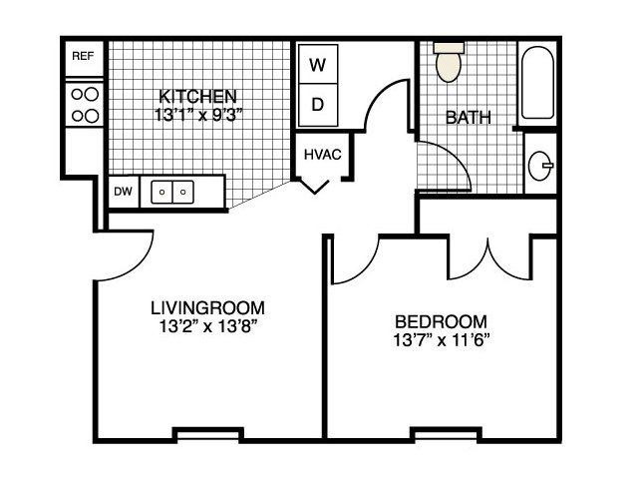

The floor plan shown is for a one- bedroom apartment. Describe the information that the floor plan shows you

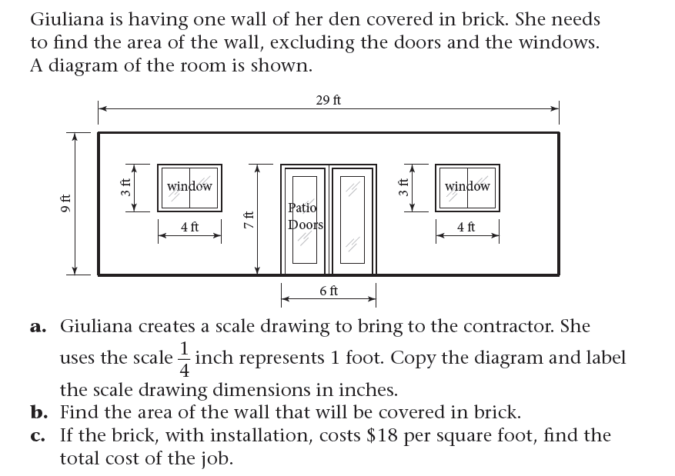

Ann obtained this list of apartments.

Use linear regression analysis to determine correlation coefficient between the square footage and the monthly rent.

Determine the regression equation. Round the numbers

in the equation to the nearest hundredth.

Use your regression equation to determine the price you might expect to pay for an 810-square foot apartment.

Use your regression equation to determine the square footage you might expect if renting a $1,710 apartment.